Retail Billing Software using Python

What is Retail Billing Software?

The Retail Billing Software is a computer-based application developed using Python programming language. It is designed to automate the billing process in a retail store. The software aims to streamline the sales and billing operations, improve efficiency, and provide an enhanced customer experience.

Aim:

* To Automate the billing process in a retail store using GUI.
* To maintain a database for products, prices, and stock information using excel.
* To caluclate the daily sales.
* To provide real-time inventory management and product management.

Libraries used in the program

**Tkinter:**Python library for building the graphical user interface (GUI).

**datetime**:Python datetime module helps to work with date aand time

**openpyxl**:Python library used to read from an excel or write to excel file.This can installed by writing pip install openpyxl in terminal.

**Note**:Before running this code two excel workbooks must be created named vegdata.xlsx and inventoryveg.xlsx.Inside inventoryveg.xlsx a excel sheet must be created named activeinventory. vegdata must be left blank but active inventory should be filled as showbelow with quantity,item and price of your choice.

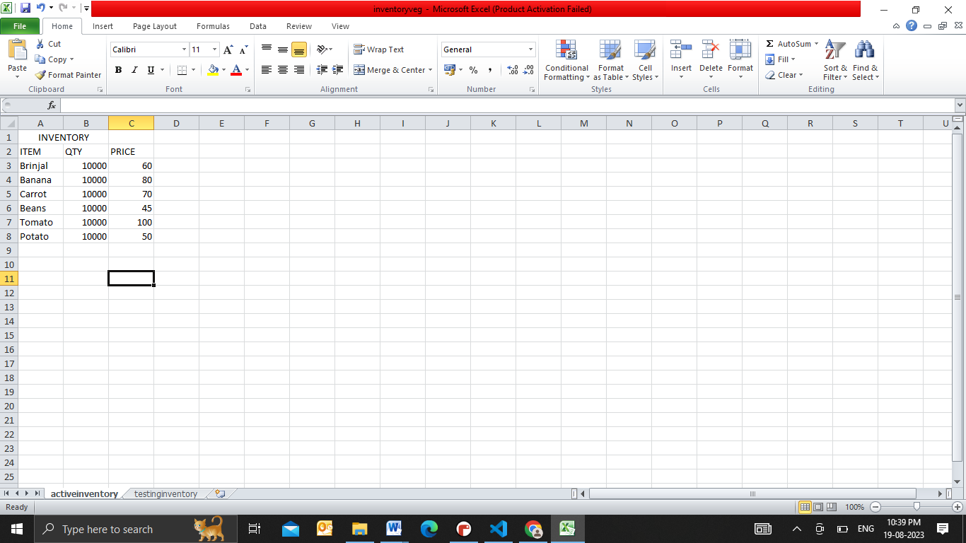

Features:

**Product Management:** Add, update, and delete products from the inventory.

**Inventory Management:** Real-time tracking of product availability and Auto-updating inventory after each transaction

**Billing Process:**

- Select products from the inventory and add them to the current transaction.

- Calculate the total amount and check Daily sales

**OUTPUT**

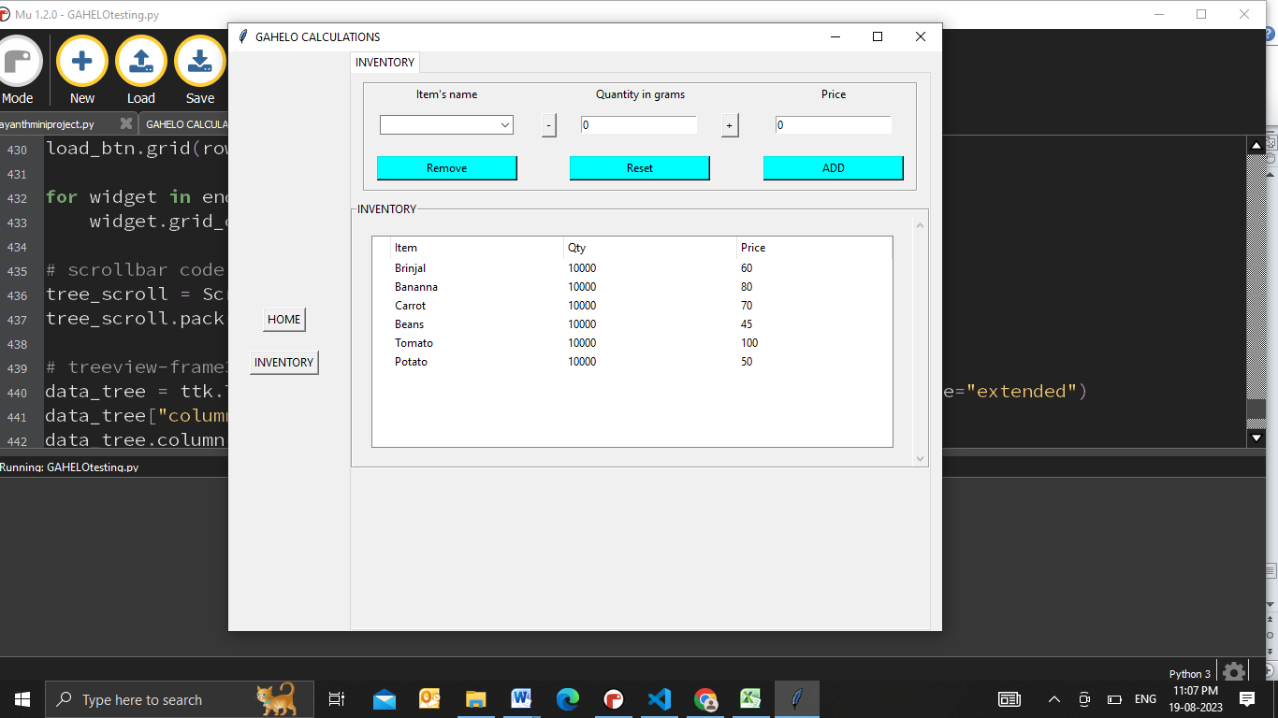

There are two tabs Home and Inventory. Real-time product availabilitycan be accessed by using Inventory Tab.This diretly access data from activeinventory excel sheet.

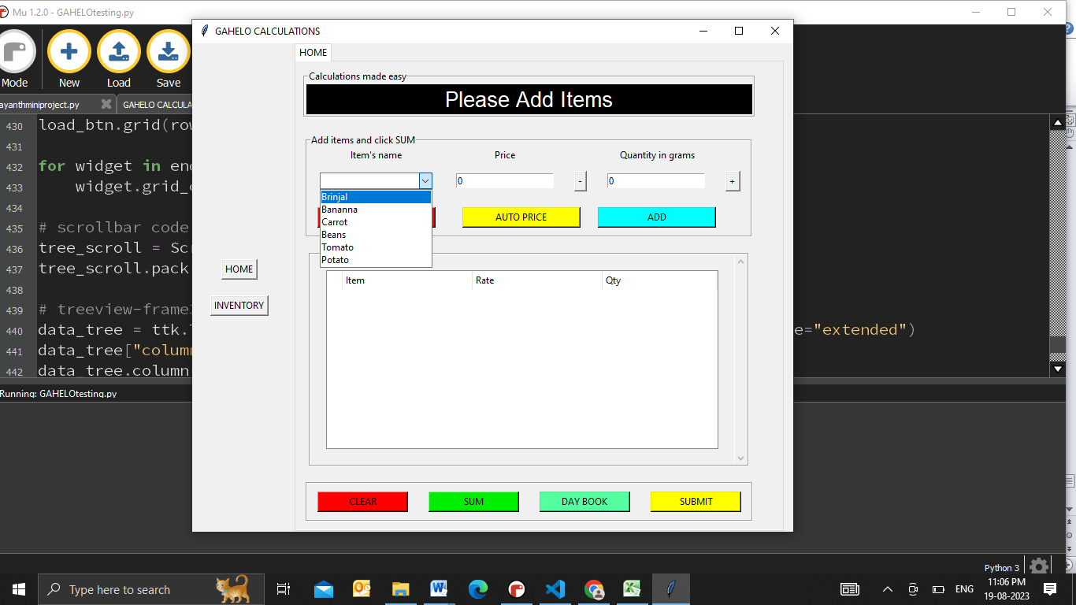

This is Home Tab. Select item from the list ,enter price or click auto price to get the price automatically and enter the required quantity.

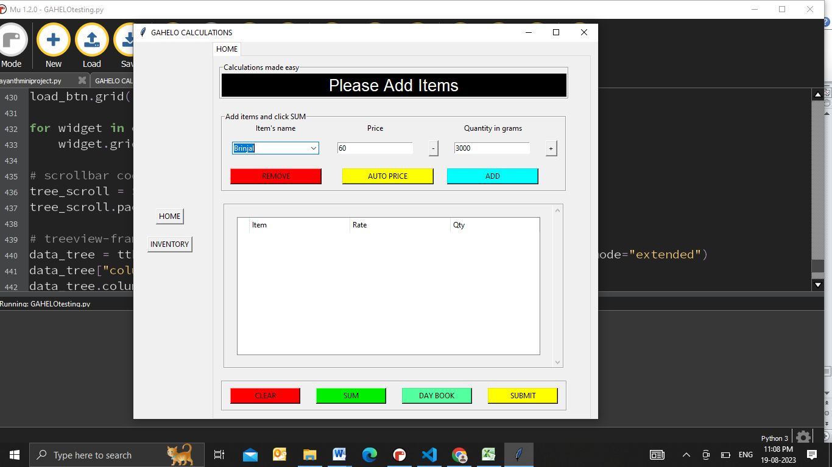

Click “AUTO PRICE” button to get the price automatically.Quantity can also be entered by using ‘+’ and ‘-’ buttons.

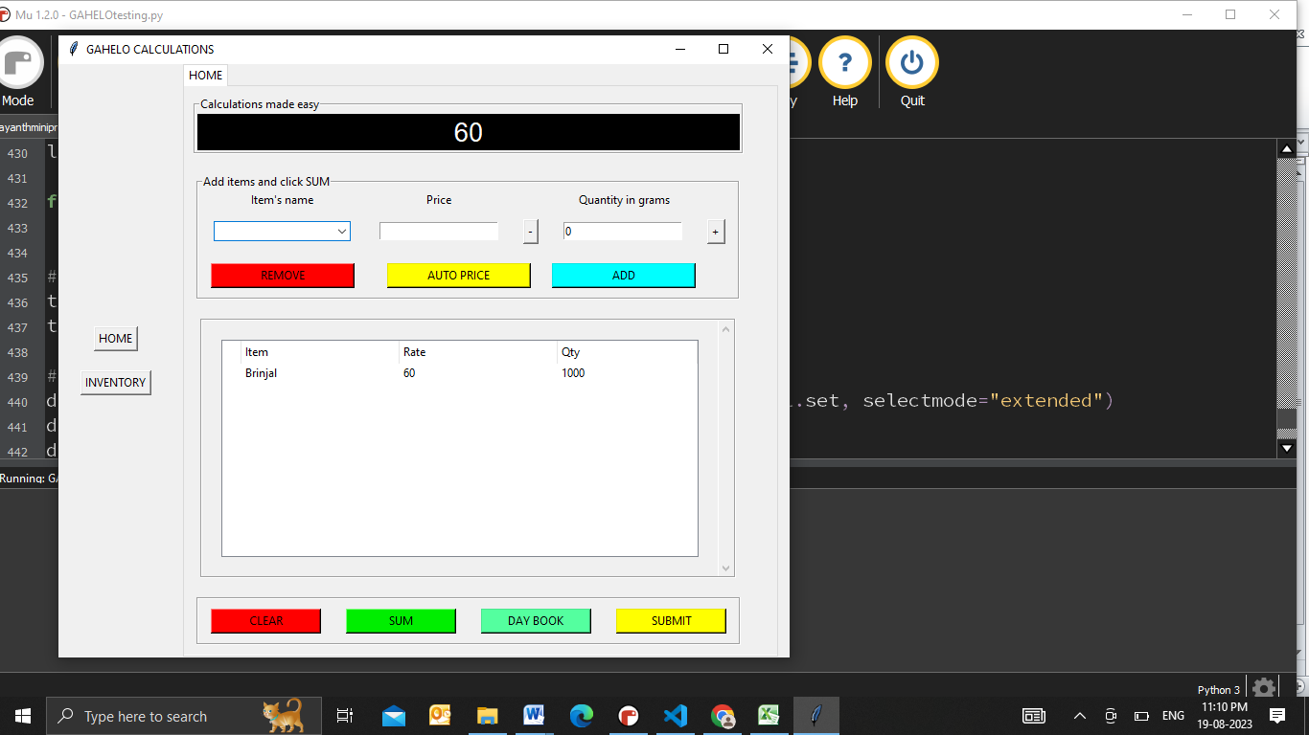

To obtain the total sum of added items ,you need to click on “SUM” button.To register the sum into Excel sheet ‘‘SUBMIT’’ should be used.

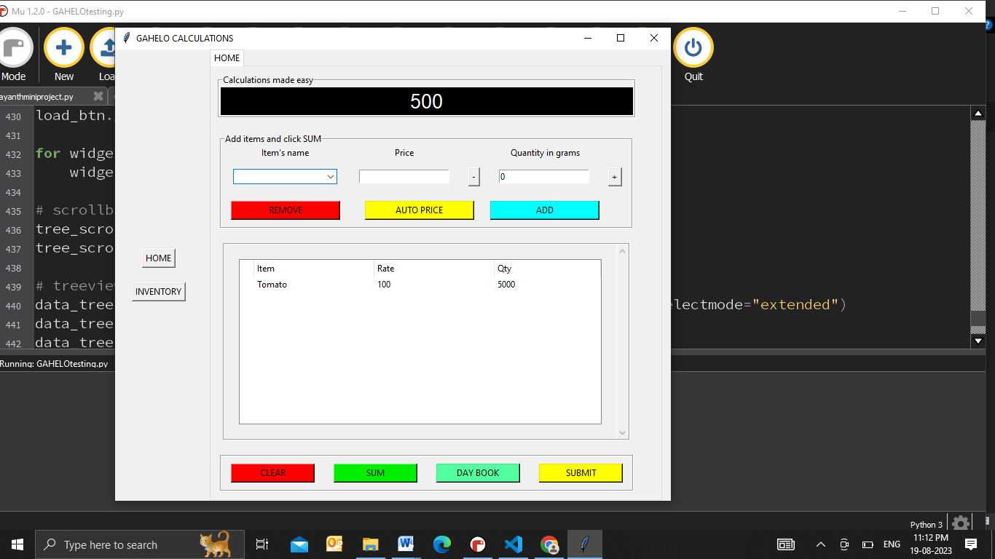

Here we have added another item and clicked on “SUBMIT”.

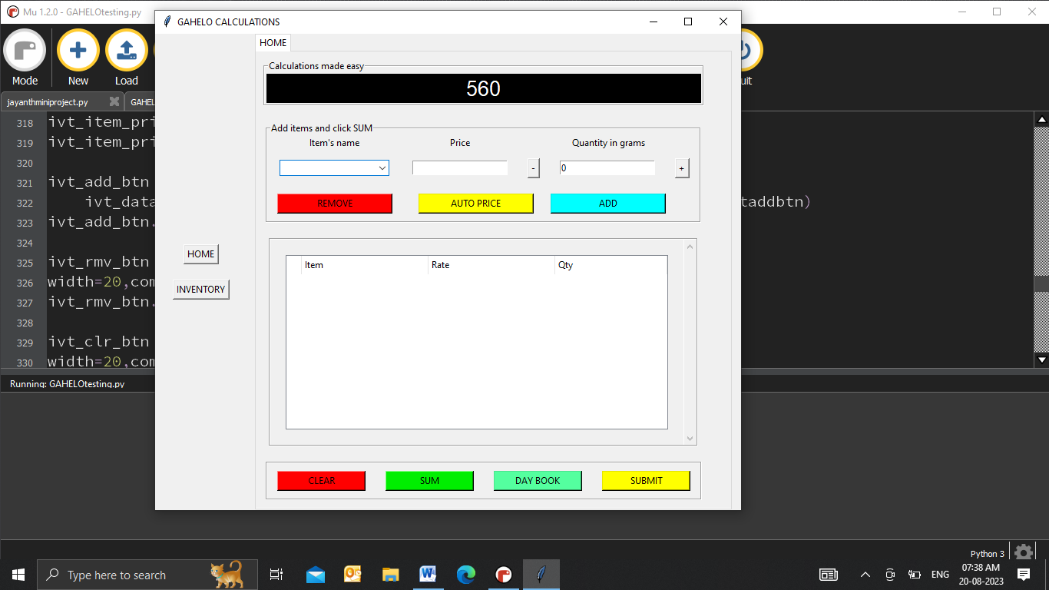 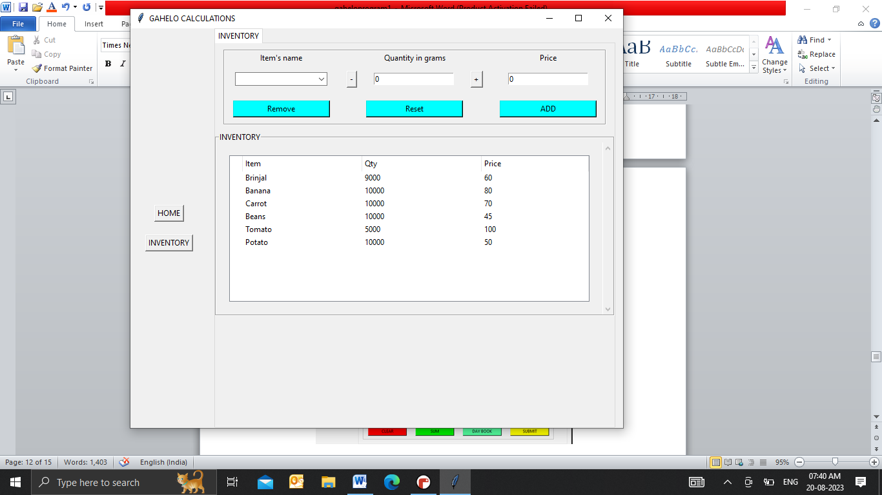

By clicking on “DAY BOOK” button we can get the total sales of current day.Inventory is updated after each transaction

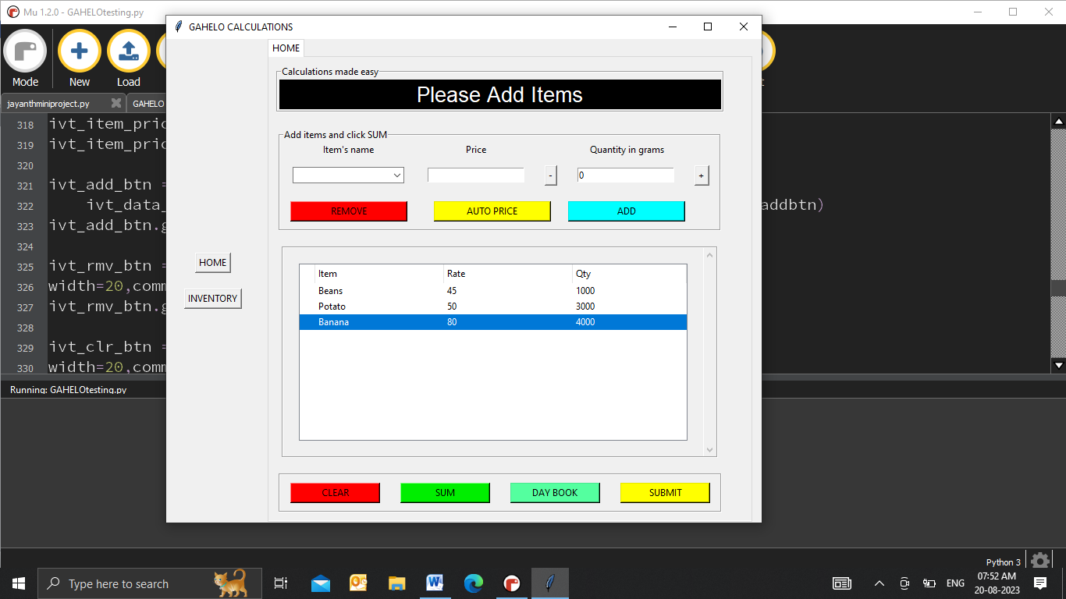 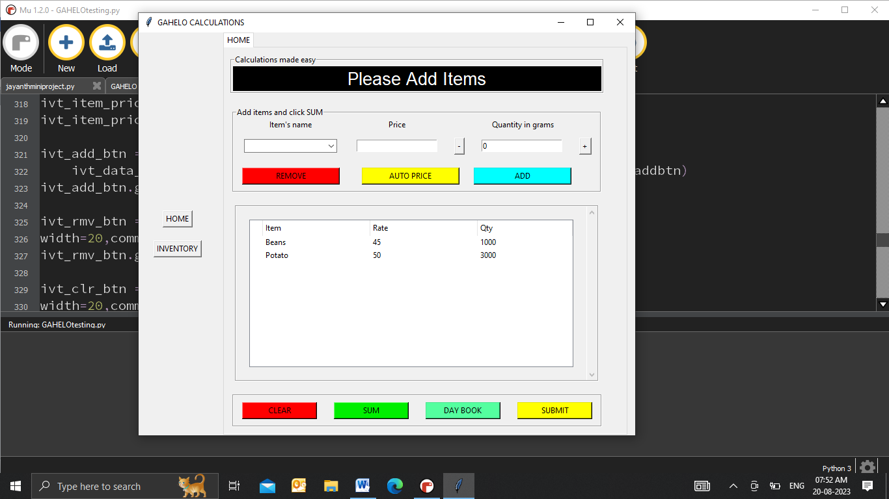

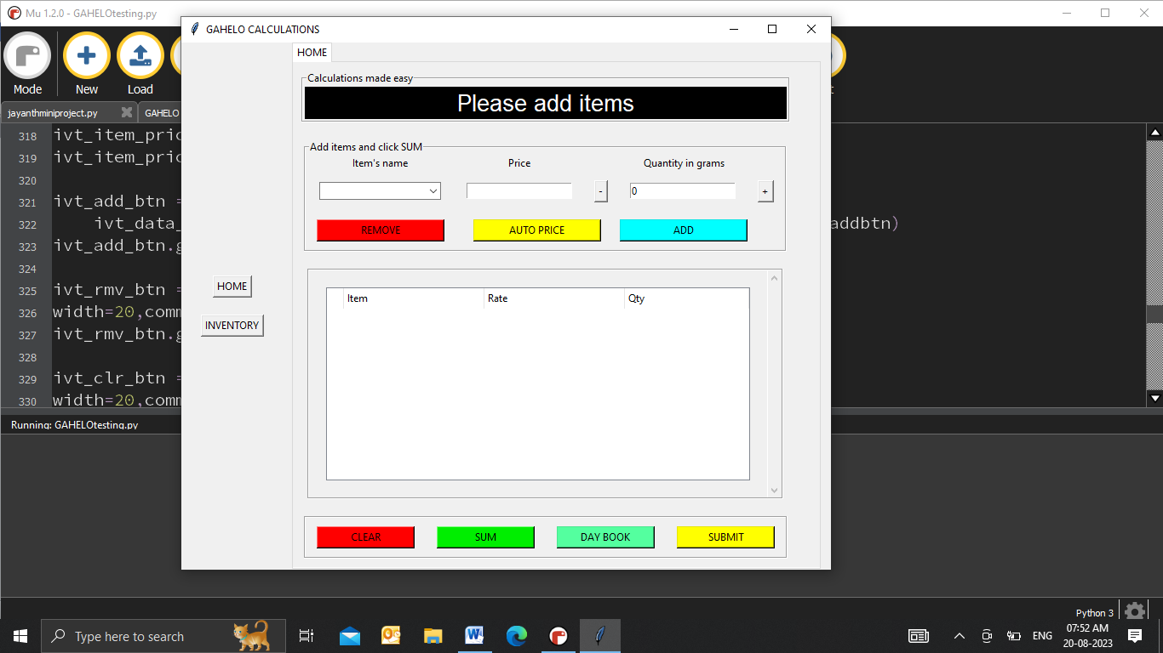Here “REMOVE” button removes the particular row selected of TreeView. “CLEAR” button clear entire Treeview as shown below.

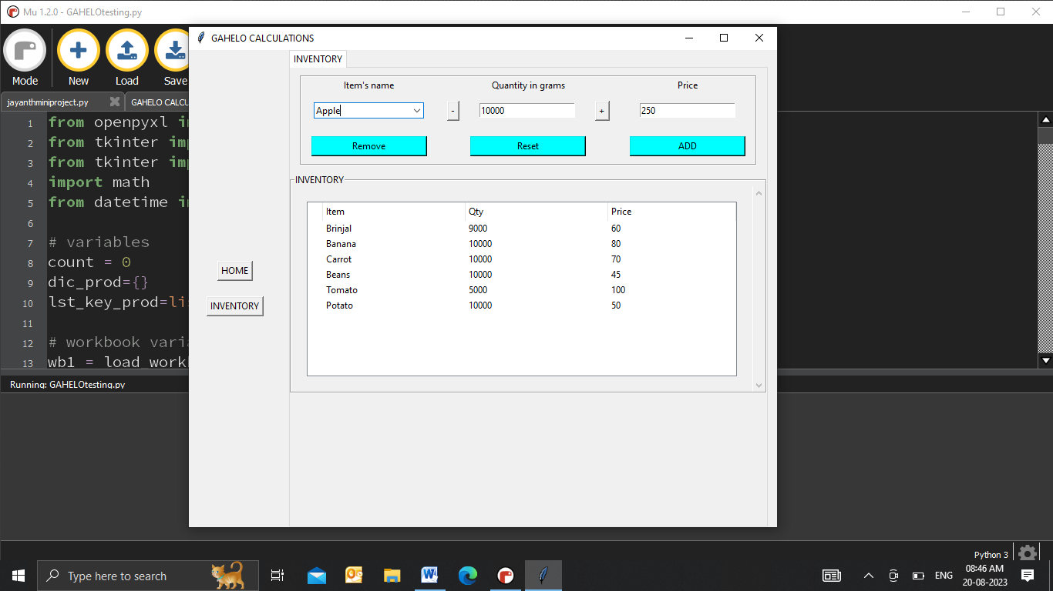

New item can be entered in the ComboBox along with quantity and price. “ADD” button should be clicked after entering the required details

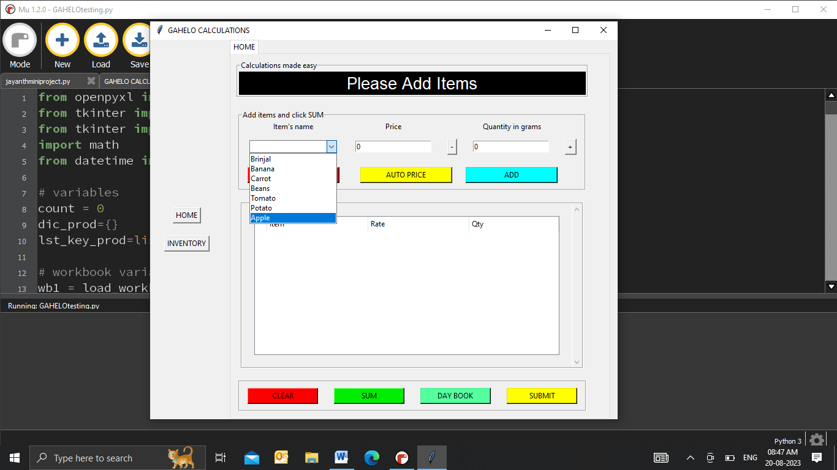 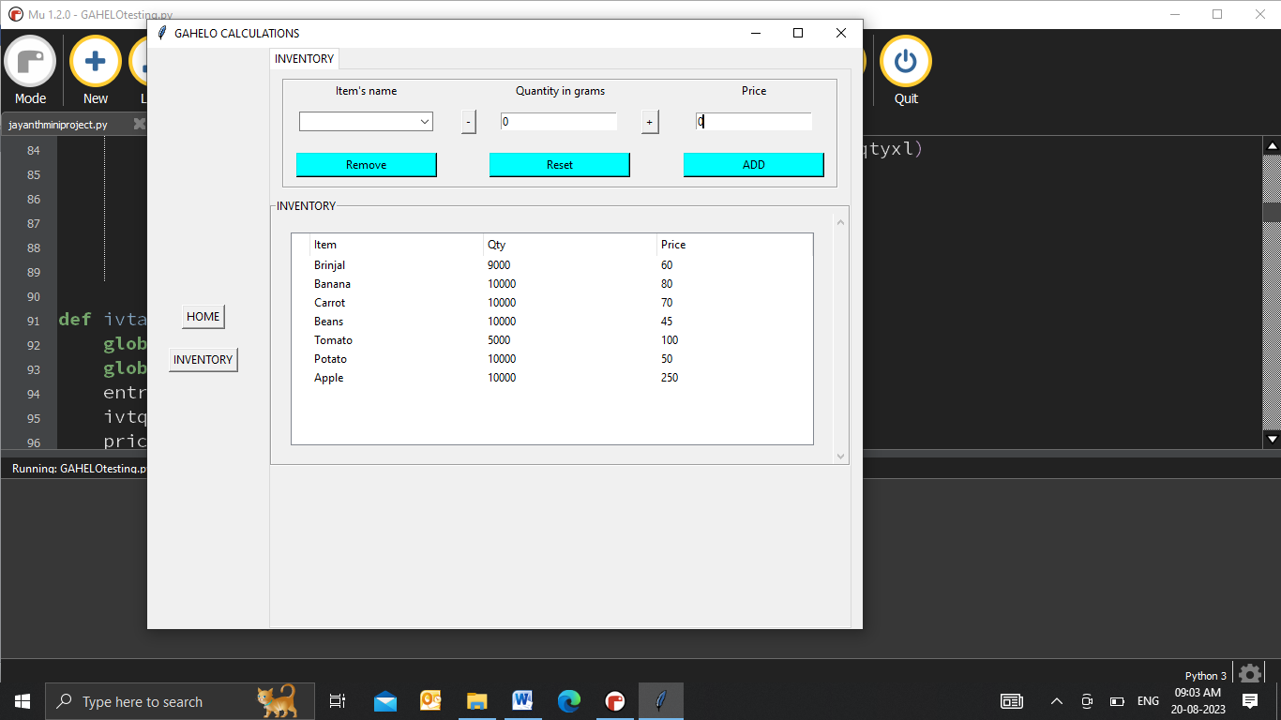

The inventory and ComboBoxes will be updated after clicking on “ADD” button.Any exisiting item can also be updated in the similar way.

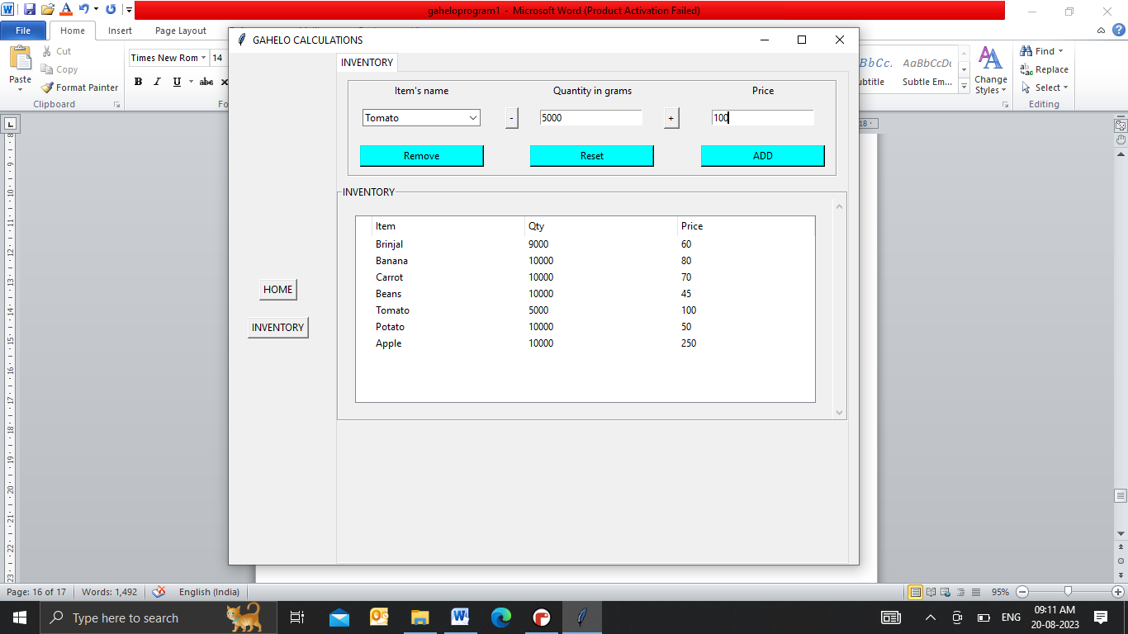

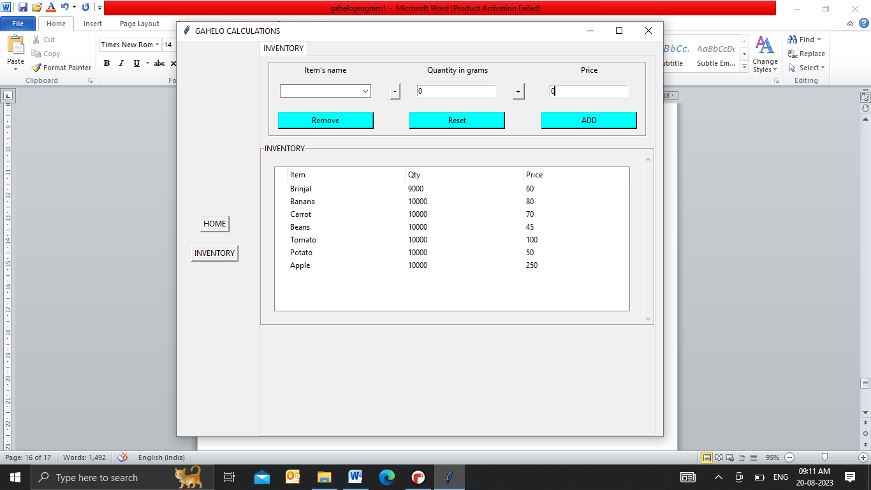

Updated Inventory

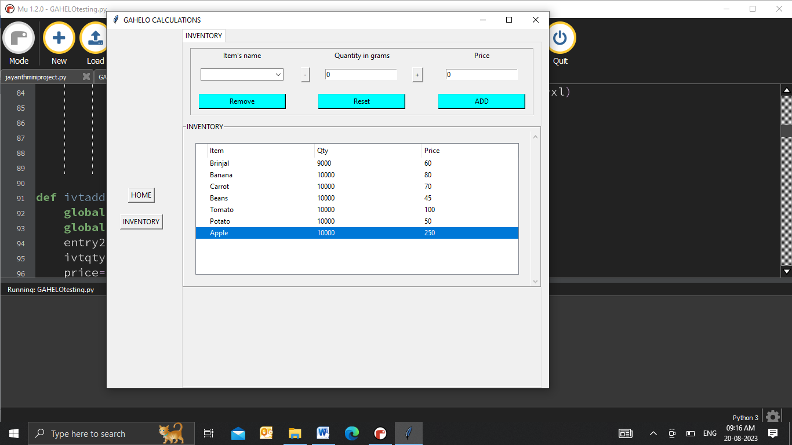

“Remove” button removes the seleted item from inventory.It also updates the ComboBox and TreeView.

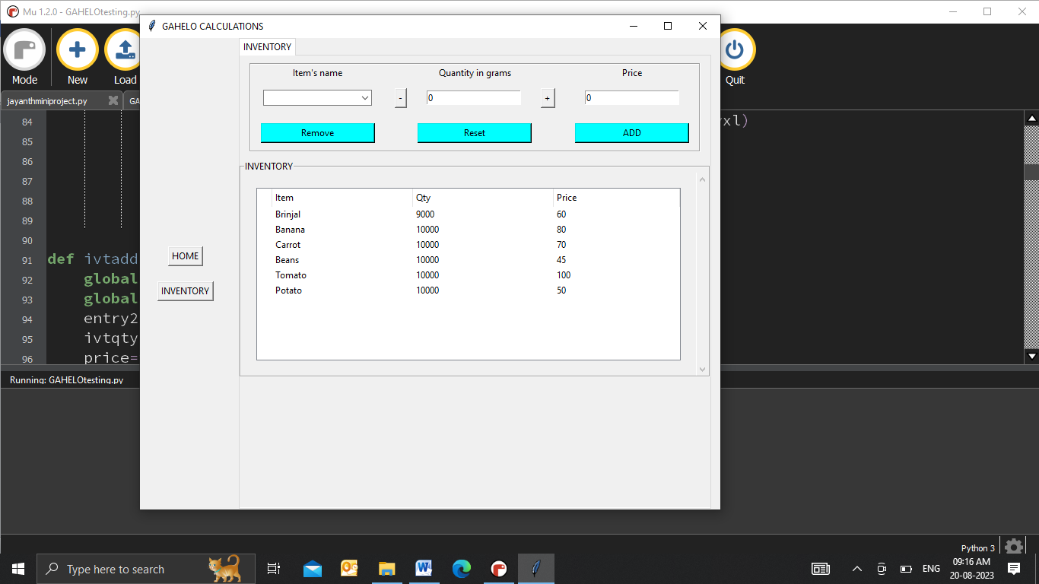 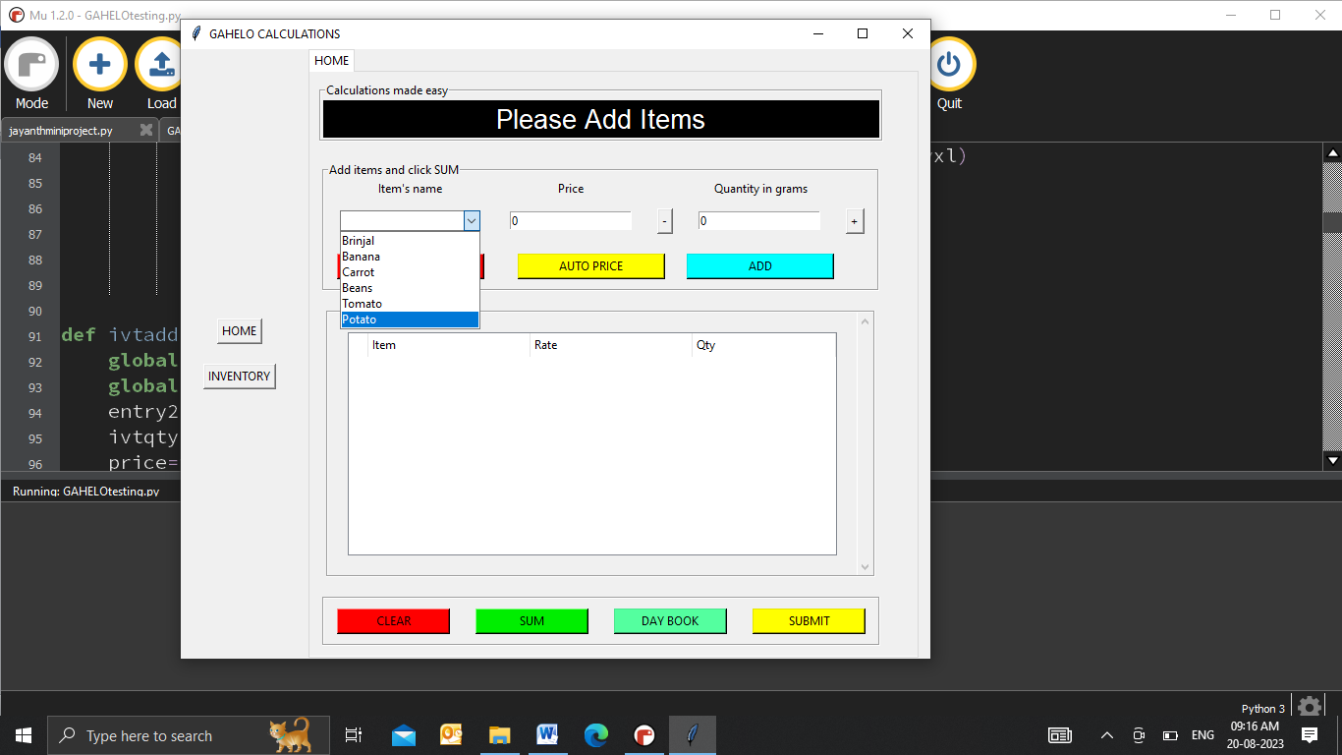

Updated inventory and ComboBox

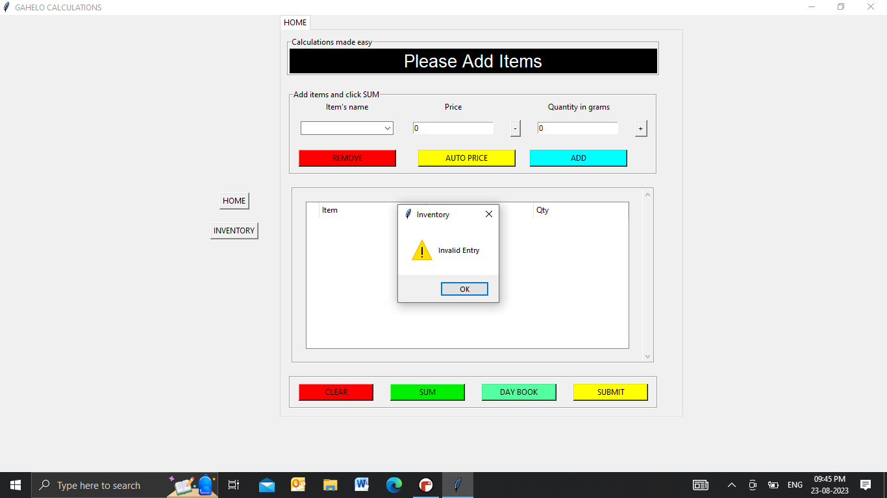

If nothing is selected in ComboBox or 0g of Quantity is selected and clicked on “ADD” button an warning message(“Invalid Entry” )pops up.

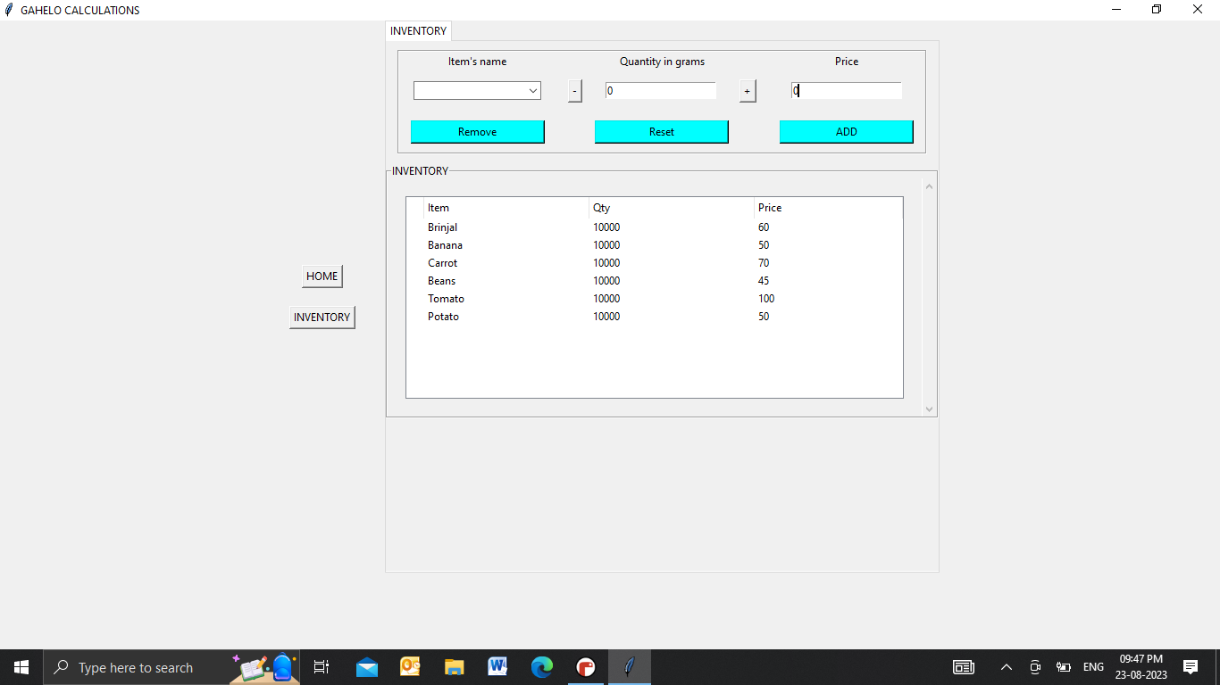

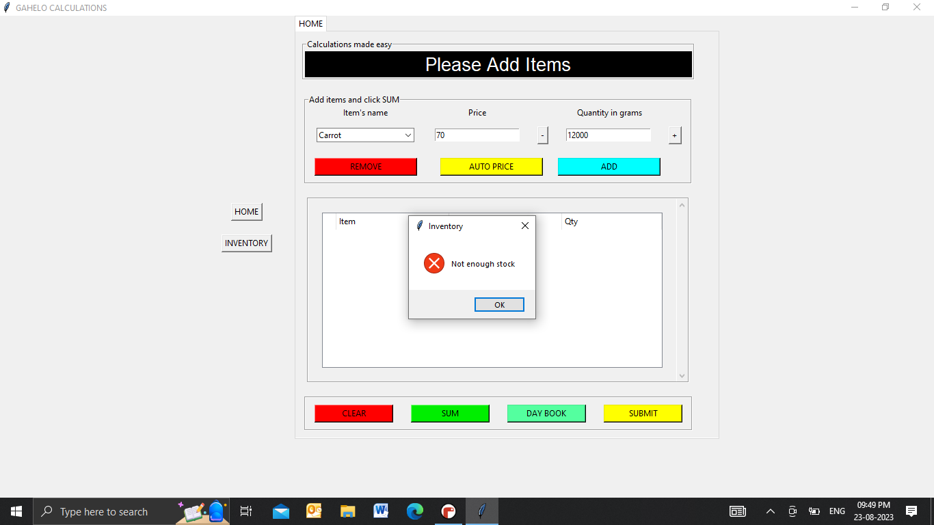

If Quantity of any item is entered excess than the quantity in inventory and clicked “ADD” button an error message(“Not enough stock”) pops up.



“Reset” button resets the entry and ComboBox



Entry and ComboBox after clicking “Reset” button

Conclusion:-

This retail billing software developed using Python offers a solution for automating the billing process.This project provides a efficient inventory management and acurrate billing.It enhances productivity,reduces manual errors and improves overall retail experience.

THANKYOU